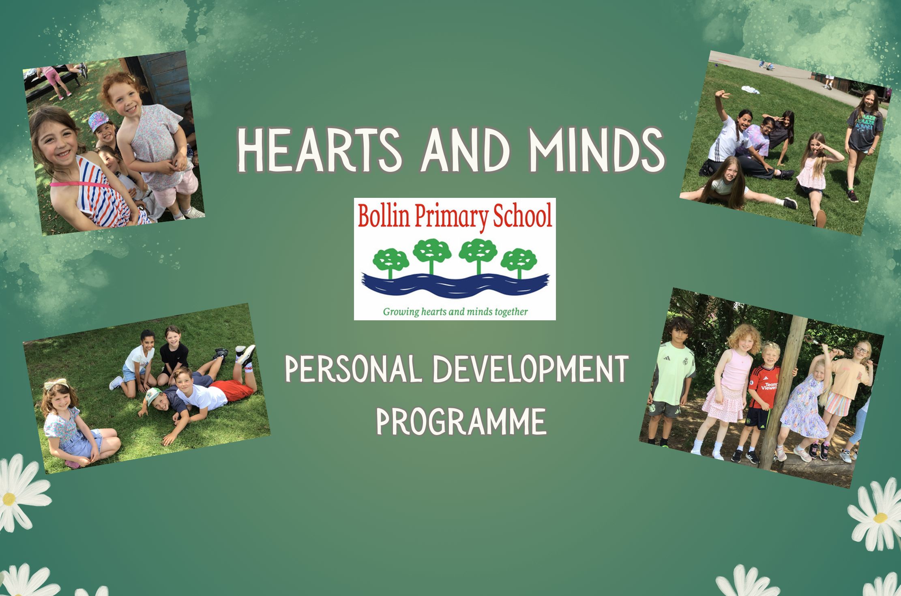

Hearts and Minds: Our Personal Development Programme
At the heart of our school is a commitment to Growing Hearts and Minds Together. This mission reflects our belief that education is about far more than academic achievement alone. While we strive for every child to learn, achieve and reach their full potential, we are equally committed to nurturing the personal qualities, values, attitudes and life skills that will enable them to flourish as happy, healthy and responsible members of society. Our Hearts and Minds Personal Development Programme represents our universal offer to every child and brings together the many experiences, opportunities and learning journeys that support children’s growth both emotionally and intellectually.
The programme is rooted firmly in our school values: We Learn and Achieve, We Work Together, We Respect Our School and Community, and We Are Kind and Care for Each Other. These values shape the culture of our school and provide the foundation for all aspects of personal development. Through Hearts and Minds, we ensure that every child experiences a curriculum and school environment that promotes equality, equity and inclusion, recognising that while all children deserve the same opportunities, some may require additional support, guidance or experiences in order to achieve and thrive.
We believe that personal development is a shared responsibility that runs through every aspect of school life. It is not confined to a single lesson or subject but is woven throughout our curriculum, enrichment opportunities, relationships, pastoral care, assemblies, educational visits, community involvement and daily interactions. This document outlines the breadth of our universal provision, demonstrating how we intentionally develop the knowledge, skills, understanding and character traits that enable children to become confident, capable and compassionate individuals. More detailed information can be found within our individual curriculum frameworks, including PSHE, Relationships Education, Online Safety and other relevant policies and guidance.
The Hearts element of the programme focuses on the spiritual, social, emotional and moral development of our pupils. It encompasses the relationships children build, the values they demonstrate, the empathy they show and the understanding they develop of themselves and others. Through meaningful experiences, reflection, discussion and participation, children learn to recognise and manage emotions, build positive relationships, appreciate diversity and contribute positively to their communities. It supports children in developing resilience, confidence, self-awareness and a strong sense of belonging, helping them to understand both their responsibilities and their potential to make a difference in the lives of others.
The Minds element of the programme focuses on equipping children with the knowledge, understanding and critical thinking skills they need to navigate an increasingly complex world. Through high-quality teaching and a broad range of experiences, children develop an understanding of British Values, including democracy, the rule of law, individual liberty, mutual respect and tolerance of different faiths and beliefs. They learn how to make informed decisions, think critically, solve problems and engage positively with society. This aspect of the programme also promotes digital literacy and online safety, enabling children to use technology responsibly, safely and confidently while understanding both its opportunities and potential risks.
Importantly, Hearts and Minds recognises that personal growth occurs through both planned learning and rich lived experiences. Our extensive programme of enrichment opportunities broadens horizons, inspires ambition and encourages children to discover new interests, talents and passions. Whether through leadership opportunities, clubs, performances, visits, community projects, sporting activities or cultural experiences, children are encouraged to develop confidence, curiosity and a lifelong love of learning.
By giving equal importance to both Hearts and Minds, we seek to educate the whole child. We want every pupil to leave our school not only with the knowledge and skills required for future success, but also with the character, values and compassion needed to contribute positively to their communities and the wider world. Through this programme, we remain committed to Growing Hearts and Minds Together, ensuring that every child is known, valued, included and empowered to thrive.

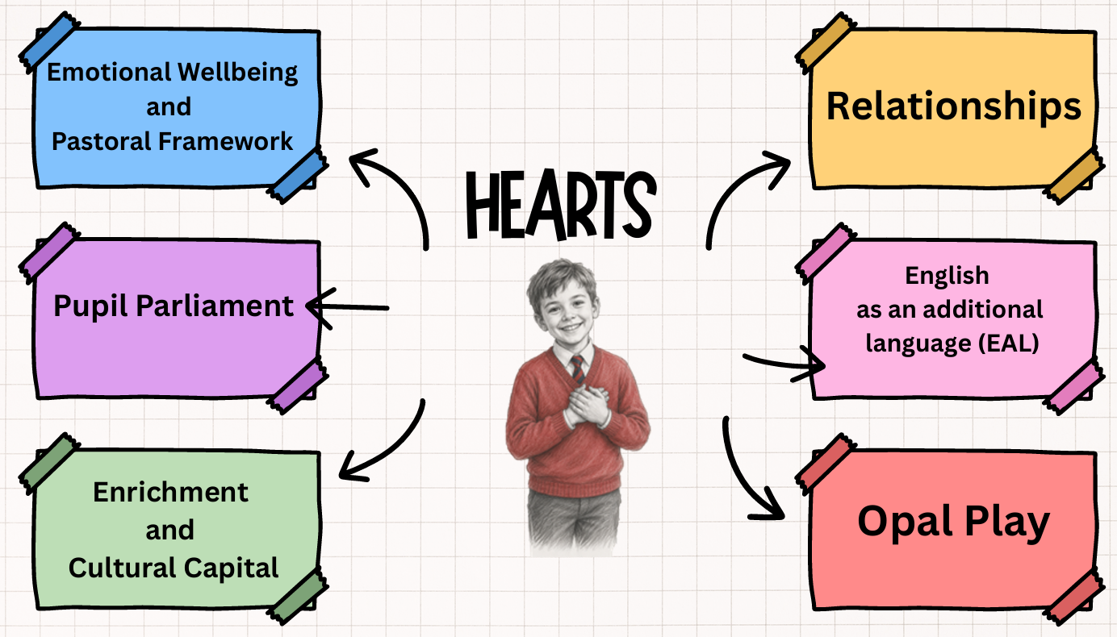

Hearts
Relationships
Value: Value: We Are Kind and Care For Each Other
Relationships sit at the very heart of our Hearts and Minds Personal Development Programme. Before children can learn effectively, develop confidence or fulfil their potential, they need to feel that they belong. They need to know that they are valued, understood and cared for by the adults and peers around them.
Our approach is closely aligned with the Trust Inclusion Model, which recognises relatedness as the foundation for thriving. The model highlights that children flourish when they feel visible, psychologically safe, connected, represented and trusted; when their voice is authentically heard and their needs are understood. As the model makes clear, feelings of belonging and connection create the conditions that enable children to develop competence, independence and ultimately achieve their best outcomes.
Human beings are fundamentally relational. Children learn about themselves through their interactions with others, and positive relationships provide the security needed to take risks, make mistakes, ask for help and grow. When children feel genuinely connected to their school community, they are more likely to engage, participate and develop the resilience required to overcome challenges. Strong relationships also help children develop emotional literacy, empathy, self-awareness and the skills needed to build healthy relationships throughout their lives.
At our school, we believe that every interaction matters. We prioritise authentic listening, kindness, respect and understanding, ensuring that children feel seen, heard and valued. Through positive relationships with adults and peers, children learn how to communicate effectively, resolve conflicts, appreciate different perspectives and contribute positively to their community.
Relationships are therefore not simply one element of personal development; they are the thread that runs through everything we do. They underpin our commitment to inclusion, equity and wellbeing, helping every child develop a strong sense of identity and belonging. By creating an environment where children feel safe, connected and understood, we lay the foundations for both happy hearts and successful minds.
Trust Inclusion Model
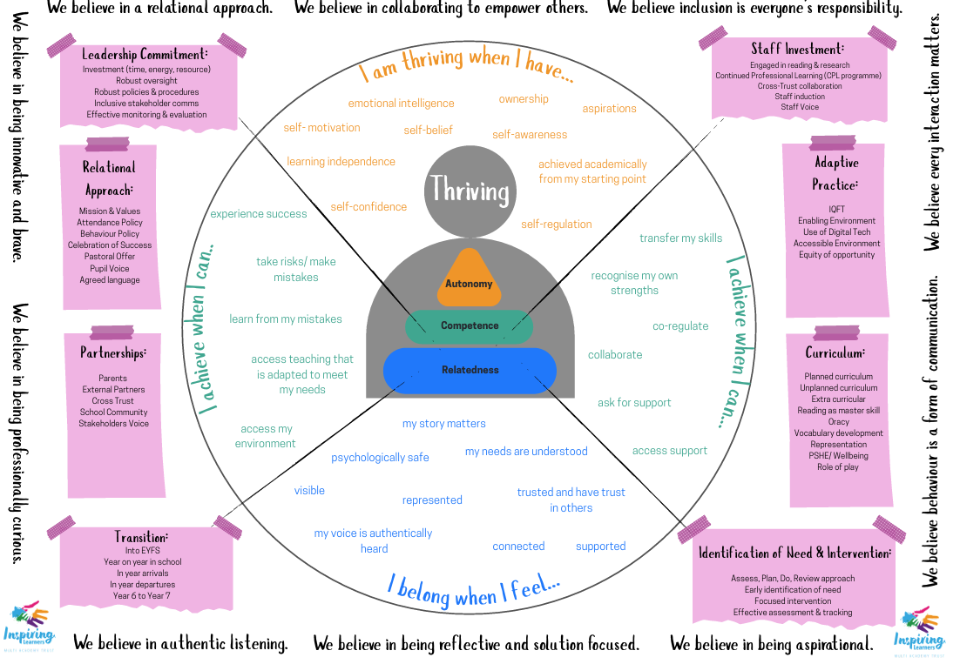Hearts
Emotional Wellbeing
Value: We Are Kind and Care For Each Other
In living out our school mission of Growing Hearts and Minds Together, we are committed to developing children's hearts through a strong focus on Emotional Wellbeing. We aim to nurture emotionally aware, resilient and self-regulating children who feel a strong sense of belonging within our school community. Through the consistent use of Zones of Regulation, My Hidden Chimp, our Pastoral Framework and engagement with the Trafford Belong Project, pupils are equipped with the knowledge, language and strategies to recognise, understand and manage their emotions. By fostering a culture of inclusion, belonging and psychological safety, we support children to develop positive relationships, build confidence and strengthen their emotional resilience so that they are able to belong, achieve and thrive.
Children demonstrate increasing emotional literacy and are able to identify, express and regulate their emotions using a shared language and toolkit of strategies. They understand how emotions influence behaviour and can independently apply self-regulation techniques when faced with challenge, change or adversity. Pupils show empathy, respect and compassion towards others, contributing positively to an inclusive community where everyone feels valued, connected and supported. Through effective pastoral provision and a strong sense of belonging, children develop the confidence, resilience and wellbeing needed to engage fully in school life. As a result, they are empowered to belong within their community, achieve their potential and thrive both now and in the future.
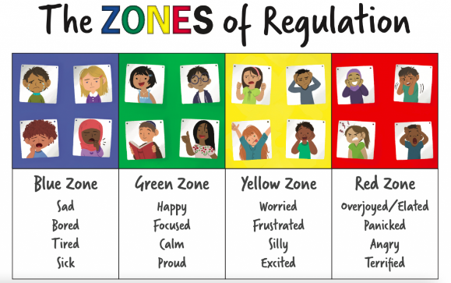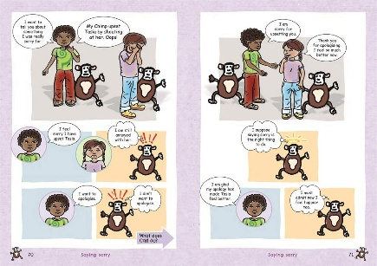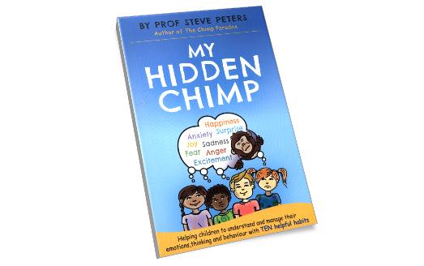
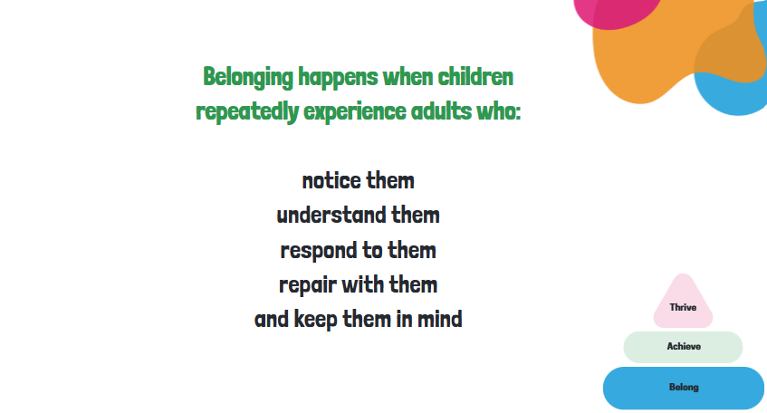
Bollin Pastoral Process
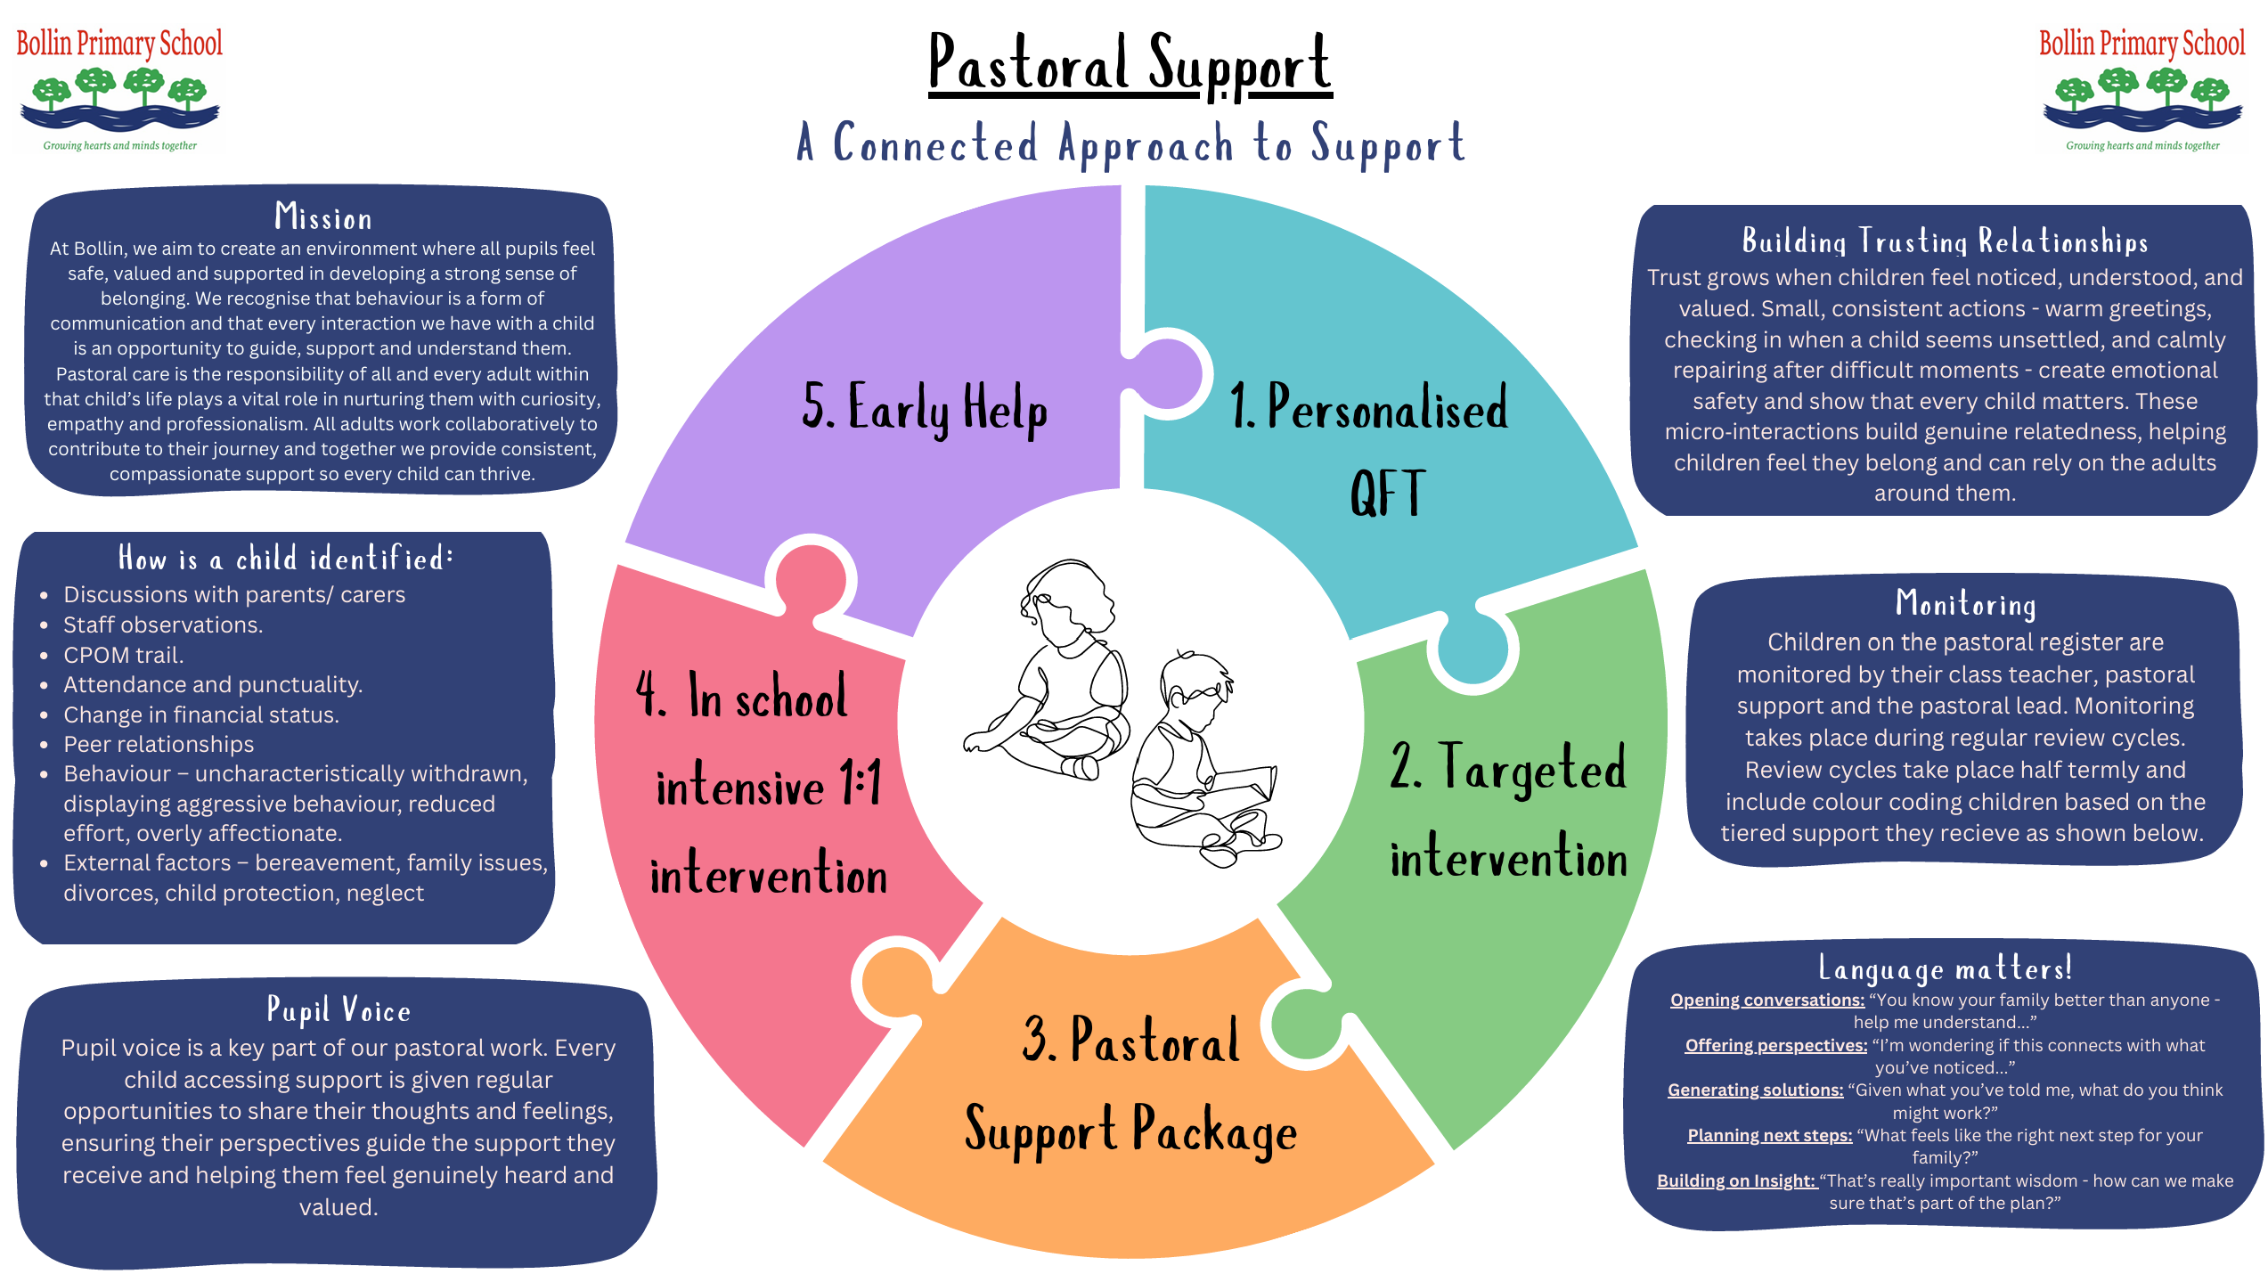

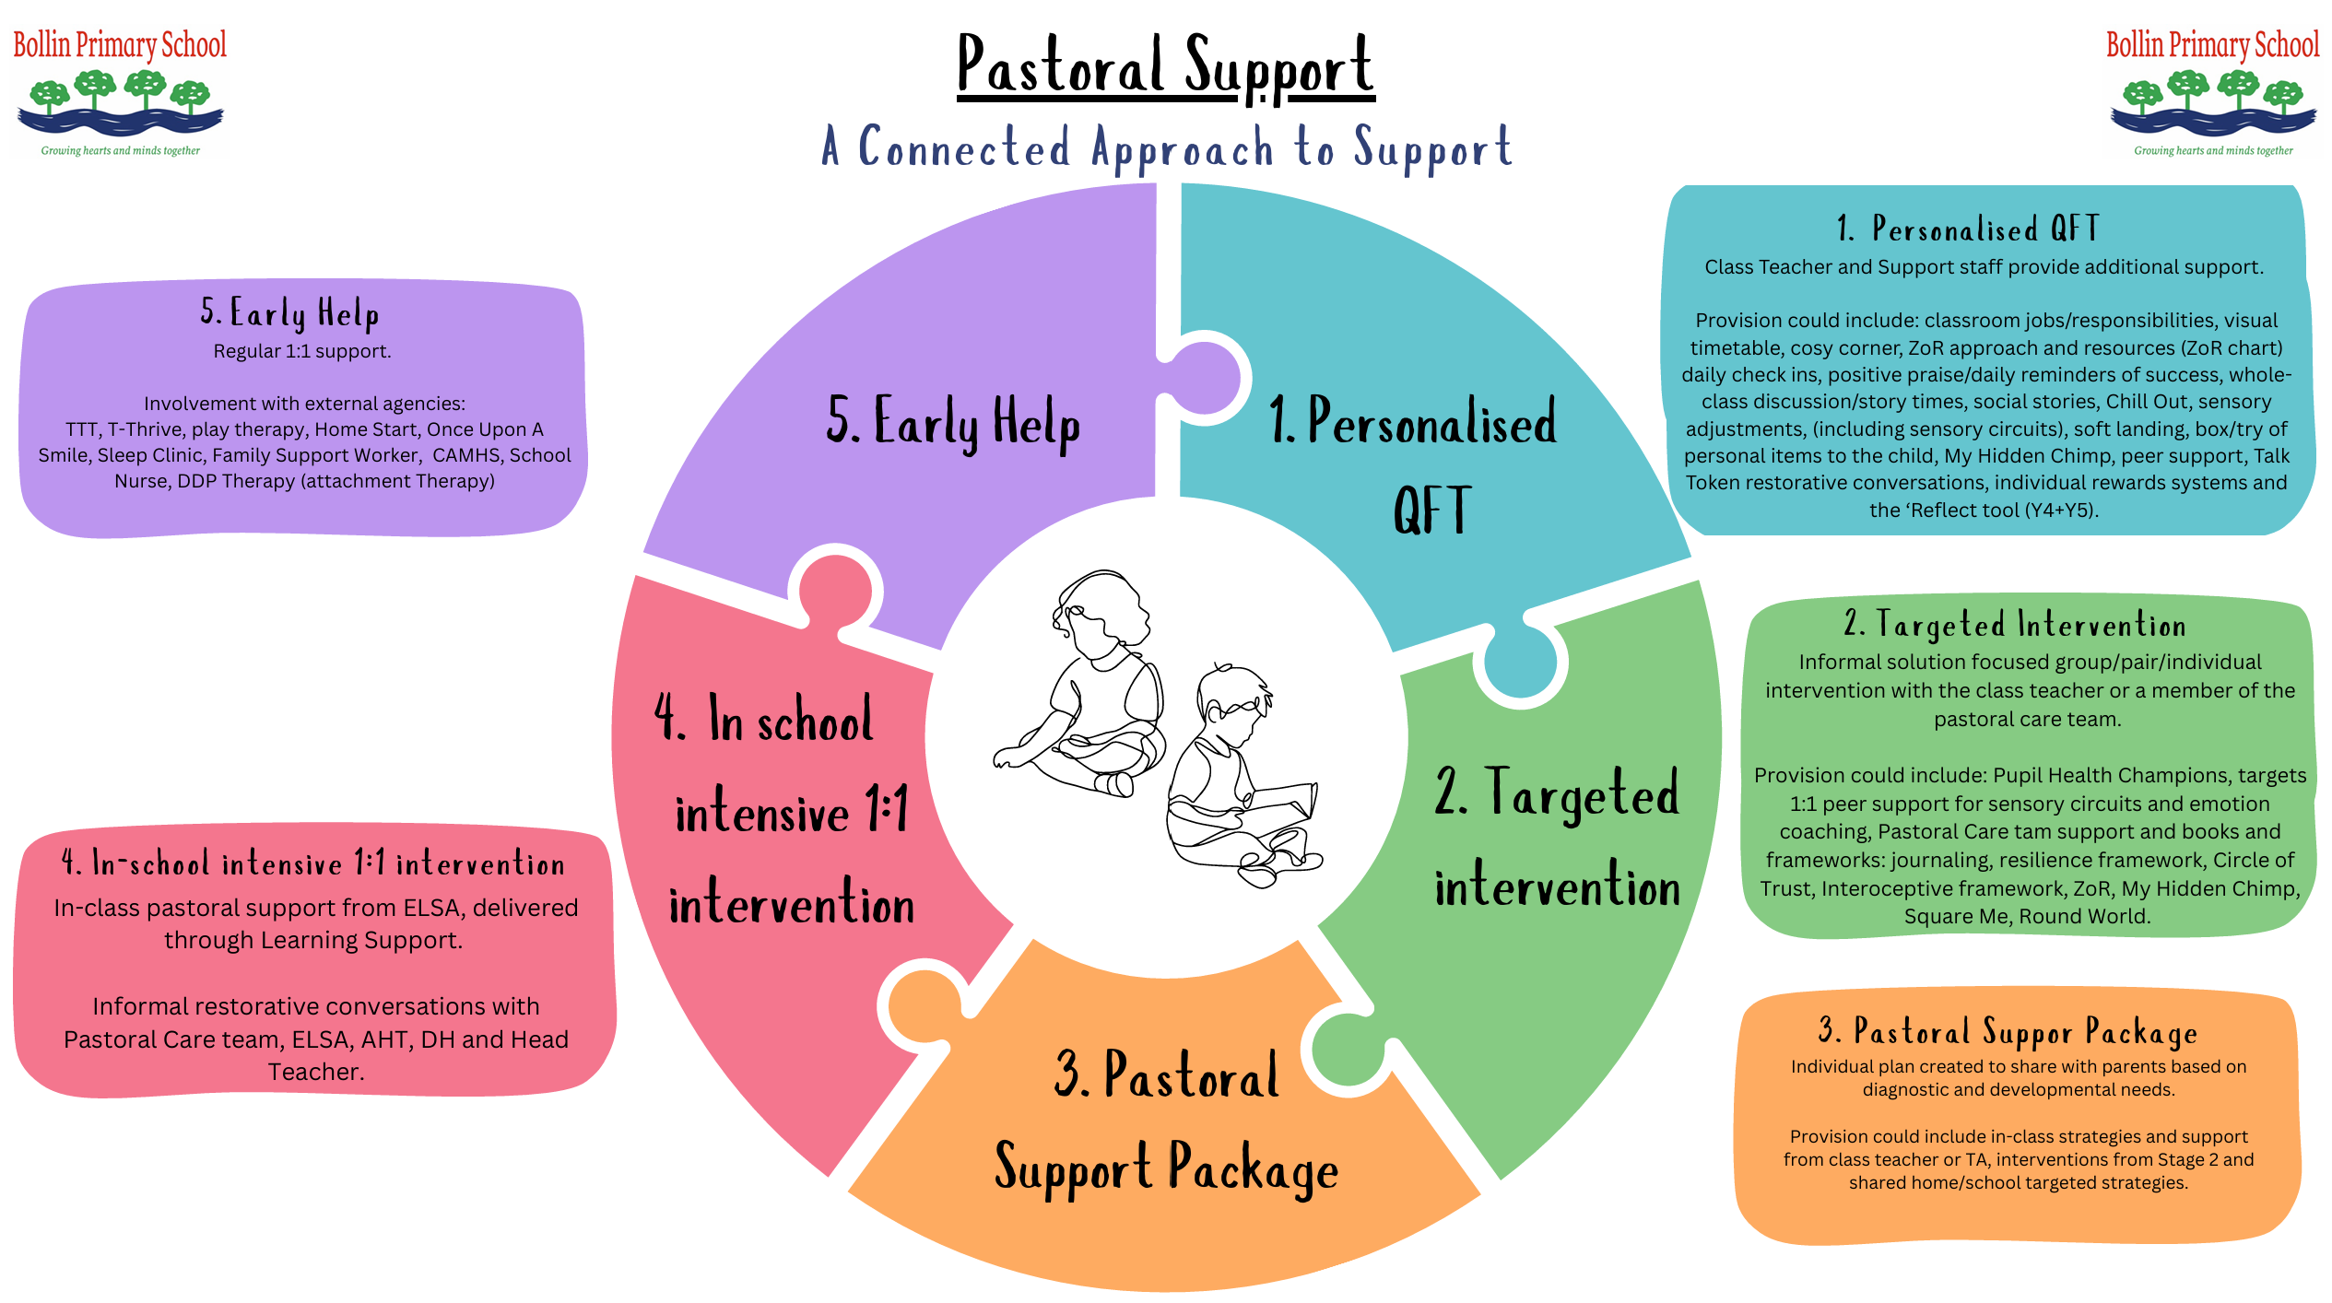

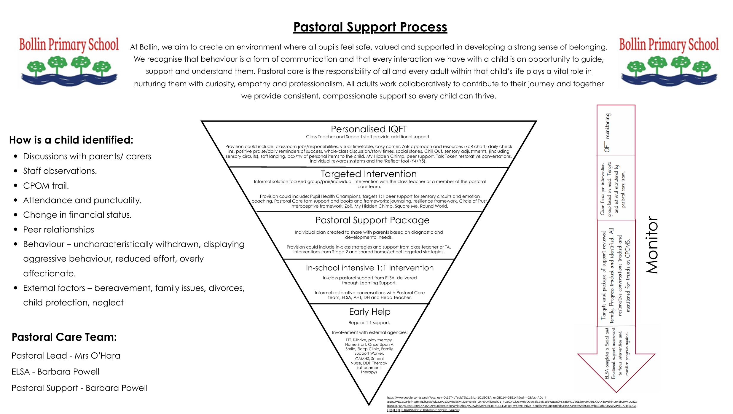

Hearts
EAL (English as an Additional Language)
Value: We Learn and Achieve
In living out our school mission of Growing Hearts and Minds Together, we are committed to ensuring that every child who speaks English as an Additional Language feels welcomed, valued and empowered to succeed. We recognise that multilingualism is a strength and that every child brings a unique cultural heritage, set of experiences and linguistic skills that enrich our school community.
Our EAL provision is built around four key pillars: Induction, Assessment, Teaching and Wider School Inclusion. Through a carefully planned induction process, we ensure that children and families experience a warm welcome and a smooth transition into our school community. Through effective assessment, we identify language needs and prior learning so that support can be tailored appropriately from the outset. High-quality teaching enables pupils to develop confidence and competence in English while accessing the full curriculum, and our wider school approach celebrates languages, cultures and diversity, ensuring that every child feels represented and included.
We aim to create an environment where children are proud of their identity, develop confidence in using English as a tool for learning and communication, and participate fully in all aspects of school life. Through this approach, we enable every child to belong, achieve and thrive.
Children with EAL feel a strong sense of belonging from their first day at Bollin and are welcomed into a community that values and celebrates diversity. Through effective induction processes, pupils settle quickly and build positive relationships with peers and adults. Through robust assessment and responsive teaching, children make strong progress in their acquisition of English and are able to access learning successfully across the curriculum.
Pupils develop the confidence to communicate, contribute and participate fully in school life while maintaining pride in their home language, culture and identity. They experience an inclusive environment where differences are recognised as strengths and where all children are given the opportunity to succeed.
As a result, children become confident, capable and resilient learners who achieve their full potential academically, socially and emotionally. They are empowered to belong within our community, achieve highly and thrive as multilingual, culturally aware citizens of the future.
The Four Pillars of EAL Provision
1. Induction
A welcoming and supportive transition process that gathers key language and background information, builds relationships with families, reduces anxiety and ensures children feel safe, valued and ready to learn from their very first day.
2. Assessment
Early and ongoing assessment of language proficiency, prior learning and individual needs to inform tailored support, identify strengths and ensure pupils make strong progress in both language acquisition and curriculum learning.
3. Teaching
High-quality, inclusive classroom practice that develops English language skills alongside curriculum knowledge through modelling, visual support, structured talk, vocabulary development and meaningful opportunities for communication.
4. Wider School
A culture that celebrates diversity, values home languages and promotes inclusion through events, curriculum experiences, assemblies and opportunities for children and families to share and celebrate their cultural heritage.
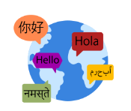
Hearts
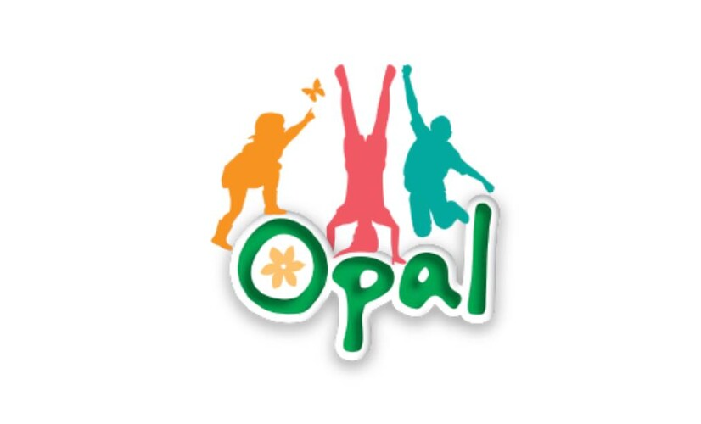
Opal Play
Value: We Respect our School and Community; We Work Together
In living out our school mission of Growing Hearts and Minds Together, we recognise that play is a vital part of children's social, emotional and physical development. Through our OPAL (Outdoor Play and Learning) Programme, we are committed to providing rich, inclusive and engaging play opportunities that enable every child to explore, create, collaborate and take appropriate risks in a safe and supportive environment.
We believe that high-quality play develops children's hearts and minds by fostering creativity, resilience, independence and positive relationships. Through access to a diverse range of play experiences, children learn to solve problems, negotiate, make decisions and develop confidence in themselves and others. By creating a play environment where all children feel valued, included and inspired, we strengthen our community and support every child to belong, achieve and thrive.
Children engage in purposeful, enjoyable and inclusive play experiences that support their physical, social and emotional wellbeing. They develop confidence, resilience and independence through opportunities to lead their own play, take manageable risks and solve problems creatively. Pupils demonstrate strong communication and cooperation skills, building positive relationships across different ages and backgrounds.
As a result, children feel happy, safe and connected within the school community. They show increased self-esteem, improved social skills and greater emotional resilience, which positively impacts their readiness to learn and overall wellbeing. Through a culture that values play as a fundamental part of childhood, pupils develop the confidence, character and life skills needed to belong within their community, achieve their potential and thrive throughout their lives.

Hearts

Pupil Parliament
Value: We Work Together
In living out our school mission of Growing Hearts and Minds Together, we are committed to ensuring that every child has a meaningful voice and the opportunity to contribute to the life and development of our school community. Through our Pupil Parliament, pupils learn that their opinions are valued and that they can make a positive difference to the world around them.
The Bollin House of Parliament provides authentic leadership opportunities through four key departments: the Department for Education and Equality, the Department for Health and Wellbeing, the Department for Digital Culture, and the Department for the Environment. Through these departments, children develop confidence, responsibility, leadership skills and an understanding of democratic processes. They are encouraged to represent the views of their peers, champion inclusion, influence decision-making, and contribute to school improvement initiatives. By empowering pupils to actively participate in shaping their school experience, we nurture a strong sense of belonging, agency and citizenship, enabling every child to belong, achieve and thrive.
Children understand that their voice matters and are confident in expressing their views respectfully and constructively. Through participation in Pupil Parliament, pupils develop leadership skills, teamwork, responsibility and an appreciation of democratic values. They actively contribute to improvements within the school, promoting equality, wellbeing, digital responsibility and environmental sustainability.
As a result, children feel valued, listened to and empowered to make a positive impact within their school and wider community. They develop the confidence and character to advocate for themselves and others, creating a culture where all children feel they belong. This increased sense of ownership, responsibility and engagement supports pupils to belong within the school community, achieve their personal potential and thrive as active, responsible citizens of the future.

Hearts
Enrichment and Cultural Capital
Value: We Respect our School and Community
Enrichment and cultural capital are essential elements of personal development because they broaden horizons, create aspiration and help children make sense of the world around them. While academic learning provides children with knowledge and skills, enrichment helps them develop curiosity, confidence, character and a deeper understanding of themselves and others. For many children, and particularly those from disadvantaged backgrounds, school plays a vital role in providing experiences, opportunities and cultural knowledge that might otherwise be inaccessible. Our aim is to ensure that every child, regardless of circumstance, develops the experiences, vocabulary and understanding needed to thrive in modern Britain and beyond.
We believe that personal development is strengthened when children are exposed to rich and memorable experiences. Through curriculum enhancement days, themed weeks, educational visits, residential experiences, performances and visitors into school, children are given opportunities to learn beyond the classroom. These experiences bring learning to life, develop resilience and independence, and create lasting memories that help children understand their place in the wider world. Residential visits, in particular, provide valuable opportunities for children to build confidence, develop relationships, take on responsibility and challenge themselves in new environments.
Reading sits at the heart of our approach to cultural capital. We intentionally flood our curriculum with high-quality and diverse texts that act as both windows and mirrors. Children need mirrors that reflect their own experiences, identities and communities so that they feel represented, valued and understood. Equally, they need windows into lives, cultures, perspectives and experiences different from their own, helping them develop empathy, understanding and respect for others. Through carefully chosen texts, children encounter a wide range of people, places, histories and ideas that broaden their knowledge and challenge their thinking.
We further enrich children's experiences through a commitment to regular author visits and literary events across every key stage. Meeting authors allows children to see themselves as readers, writers and creators, inspiring a lifelong love of reading and encouraging ambition. These opportunities help children understand that books are created by real people with stories worth sharing and voices worth hearing.
A central outcome of this work is the development of language. We recognise that vocabulary is one of the strongest predictors of future success and plays a crucial role in unlocking learning across the curriculum. Through rich texts, meaningful discussion, oracy opportunities, experiences and encounters beyond the classroom, we explicitly build children's vocabulary and background knowledge. The more children know, see, hear and experience, the more confidently they can communicate, engage with new learning and participate fully in society.
By providing a rich programme of enrichment and cultural experiences, we strive to ensure that every child leaves our school with not only strong academic foundations but also the knowledge, confidence, curiosity and cultural awareness needed to flourish. Through these opportunities, children develop a broader understanding of the world, a stronger sense of self and a greater capacity to contribute positively to their communities and beyond.

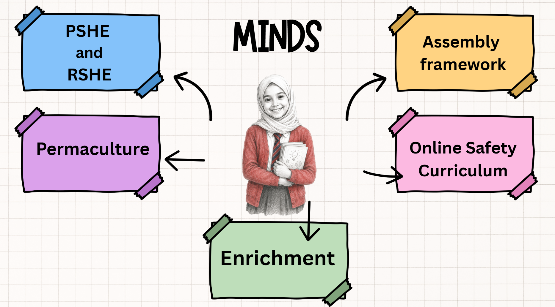

Minds
PSHE and RSHE
Value: We Learn and Achieve; We Work Together; We are Kind and Care for Each Other; We Respect our School and Community
Developing Knowledge, Character and Life Skills
In living out our school mission of Growing Hearts and Minds Together, we are committed to ensuring that every Bollin child develops the knowledge, skills, understanding and character needed to lead healthy, happy and successful lives.
Personal, Social, Health and Economic Education (PSHE), including Relationships, Sex and Health Education (RSHE), is a vital part of this commitment. Through a carefully planned and progressive curriculum, children develop the understanding, confidence and resilience needed to navigate the opportunities and challenges they will encounter throughout their lives.
PSHE provides children with opportunities to explore important aspects of both their current and future lives, including wellbeing, relationships, safety, identity, diversity, citizenship and the wider world. Through meaningful discussion, reflection and real-life contexts, children learn to express their views respectfully, make informed decisions, build positive relationships and develop the confidence to contribute positively to society.
More than simply teaching knowledge, our PSHE curriculum aims to develop the personal qualities and life skills that enable children to flourish both in school and beyond.
Building Strong Foundations in EYFS
Personal development begins in the Early Years Foundation Stage through the Think Equal programme.
Think Equal is an evidence-informed social and emotional learning curriculum that uses carefully selected stories, discussion, role play and reflective activities to develop children's emotional intelligence and social awareness. Through engaging texts and structured conversations, children learn to understand their emotions, recognise the feelings of others and develop empathy, kindness and self-awareness.
Children explore important themes including friendship, inclusion, diversity, emotional regulation and conflict resolution. They learn how to express their feelings appropriately, manage disagreements positively and build healthy relationships with those around them.
By providing a strong foundation in emotional literacy and social understanding, Think Equal prepares children for their future PSHE learning and supports their wider development as confident, caring and respectful members of the school community.
PSHE and RSHE from Year 1 to Year 6
From Year 1 onwards, children follow a carefully sequenced PSHE curriculum which includes statutory Relationships, Sex and Health Education (RSHE).
At primary school, RSHE focuses on helping children understand:
- healthy and respectful friendships and relationships;
- different family structures and the importance of caring relationships;
- respect, kindness, inclusion and diversity;
- personal boundaries, privacy and consent in age-appropriate contexts;
- physical and emotional wellbeing;
- keeping themselves safe, both online and offline;
- personal growth and development, including puberty in upper Key Stage 2;
- how and when to seek support from trusted adults.
The primary curriculum focuses on providing children with the essential foundations for healthy relationships, positive wellbeing and informed decision-making. Learning is carefully planned to be developmentally appropriate and responsive to the needs of children at each stage of their education.
A Curriculum Designed for Life
Children study six units of learning each year, revisiting and extending key themes as they move through school. This progressive approach allows children to deepen their understanding over time while applying their learning in increasingly sophisticated ways.
The curriculum is deliberately designed around themes that are relevant to children's lives, experiences and future aspirations.
For example:
Showing Kindness to Ourselves and Others (Year 1)
This unit helps younger children understand what kindness looks like in everyday life and why it matters. Through stories, discussion and practical activities, children develop empathy, self-awareness and the ability to recognise the needs and feelings of others. They begin to understand that treating others with kindness and respect helps to build positive relationships and a strong community.
Building Healthy Habits (Year 3)
Children explore how everyday choices affect their physical and mental wellbeing. They learn about healthy routines, active lifestyles, nutrition, sleep and self-care, developing an understanding that small positive choices can have a significant impact on their overall health and happiness.
Forming Respectful Relationships (Year 4)
This unit develops children's understanding of trust, respect, communication and cooperation within friendships and families. Children learn how healthy relationships are built and maintained, while also developing strategies for managing disagreements and resolving conflict positively.
Friendships, Stereotypes and Bullying (Year 5)
Children explore the influence of stereotypes and prejudice on individuals and communities. They learn to recognise bullying behaviours, challenge unfair assumptions and celebrate diversity, helping them become active advocates for inclusion and respect.

Across the curriculum, children also explore themes including mental health and wellbeing, managing risk, online safety, personal safety, citizenship, financial understanding and future aspirations.
Developing Essential Life Skills
Through these units, children develop a wide range of transferable skills that support success both in school and beyond.
These include:
- communication and active listening;
- teamwork and collaboration;
- decision-making;
- problem solving;
- emotional regulation;
- resilience and perseverance;
- empathy and compassion;
- critical thinking;
- managing risk;
- self-reflection and self-awareness.
These life skills help children to become confident learners, positive friends and responsible citizens who are equipped to face challenges and embrace opportunities.

Bringing Learning to Life Through Literature
A distinctive feature of our PSHE curriculum is the extensive use of carefully selected, high-quality children's literature.
Each unit is rooted in powerful texts that provide meaningful contexts for discussion and reflection. Stories allow children to encounter characters, situations and dilemmas that bring abstract concepts to life and make learning more relatable and memorable.
Through literature, children are able to explore themes such as belonging, friendship, identity, resilience, diversity and inclusion in ways that feel authentic and engaging. Stories often provide a safe distance from which children can discuss sensitive issues, while helping them develop empathy and a deeper understanding of different perspectives.
By placing books at the heart of the curriculum, we create rich opportunities for children to connect their learning to the real world and to their own lived experiences.
Learning Through Talk, Discussion and Reflection
At Bollin Primary School, we recognise that some of the most valuable learning in PSHE takes place through high-quality discussion.
For this reason, children record their learning in floor books rather than traditional exercise books. Floor books provide a shared record of children's ideas, questions, reflections, photographs and collaborative work, capturing the rich dialogue that sits at the heart of the curriculum.
This approach reflects our belief that the purpose of PSHE is not simply to produce written work but to develop understanding through conversation, reflection and shared thinking.
Through carefully facilitated discussion, children learn to:
- listen respectfully to others;
- articulate their thoughts and opinions;
- consider different viewpoints;
- justify their ideas;
- challenge stereotypes and assumptions;
- reflect on their own beliefs and experiences.
These opportunities for talk help children develop confidence, empathy and critical thinking whilst strengthening the communication skills that underpin learning across the curriculum.
Preparing Children for Life Beyond Bollin
Through our PSHE and RSHE curriculum, we strive to develop children who are emotionally literate, resilient, respectful and socially responsible. We want every child to leave Bollin Primary School with a strong sense of self, a respect for others and the confidence to make positive choices throughout their lives.
By nurturing both knowledge and character, we ensure that our children are well prepared for the opportunities, responsibilities and challenges they will encounter as they continue their journey beyond primary school, truly living our mission of Growing Hearts and Minds Together.

Minds
Online Safety Curriculum
Value: We Learn and Achieve; We Work Together; We are Kind and Care for Each Other; We Respect our School and Community
Preparing Children for Life in a Digital World
In living out our school mission of Growing Hearts and Minds Together, we are committed to ensuring that all Bollin children develop the knowledge, skills and understanding needed to navigate an increasingly connected digital world safely, responsibly and confidently.
Technology is woven into almost every aspect of modern life. It influences how children learn, communicate, socialise, access information, express themselves and engage with the wider world. Whilst digital technologies provide extraordinary opportunities for creativity, collaboration and learning, they also present risks and challenges that children must be equipped to recognise and manage.
At Bollin Primary School, we believe that effective online safety education goes far beyond teaching children a set of rules. Children need to develop critical thinking, sound judgement and the confidence to make informed decisions when faced with real-life situations online. Our aim is to empower children to become responsible digital citizens who can harness the benefits of technology whilst keeping themselves and others safe.
Online Safety is therefore a key element of both our safeguarding responsibilities and our wider Personal Development Programme.
An Evolving Curriculum for an Evolving World
Unlike many curriculum areas, online safety can never stand still. The digital landscape changes rapidly and children are continually encountering new technologies, platforms and online experiences.
For this reason, our Online Safety curriculum is regularly reviewed and adapted to ensure it remains relevant and responsive to emerging trends, risks and opportunities. We recognise that the knowledge and understanding children require today may be significantly different from that required just a few years ago.
Recent developments in artificial intelligence provide a clear example. Children are increasingly exposed to AI-generated content, including chatbots, manipulated images and videos, and information that can be difficult to distinguish from reality. In response to growing national attention on the risks associated with AI and deepfake technology, our Year 6 pupils now explore how artificial intelligence works, how AI-generated content can influence opinions and decisions, and why it is important to evaluate online information critically.
By continually reviewing our curriculum, we ensure that our children are prepared not just for today's digital world but for the technologies and challenges they will encounter in the future.
Education for a Connected World
Our online safety curriculum has been developed using the Government's Education for a Connected World framework and its associated teaching resource, Project Evolve. This nationally recognised framework identifies the knowledge, skills, behaviours and attitudes that children need in order to thrive safely online.
The framework is built around eight interconnected strands that reflect the realities of children's online lives.
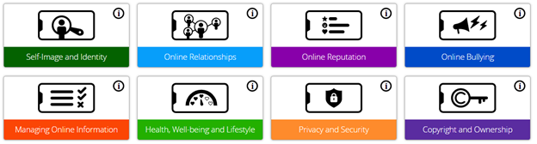
Self-Image and Identity
Children explore how the online world can influence the way people see themselves and others. They learn about digital identities, self-esteem, positive self-image and the impact of online content on beliefs and perceptions.
Online Relationships
Children learn how to build and maintain safe, respectful and positive relationships online. They develop an understanding of appropriate online behaviour, communication and the importance of seeking support when interactions feel unsafe or uncomfortable.
Online Reputation
Children learn that the information shared online contributes to a digital footprint that may remain available long into the future. They consider how online actions can affect relationships, opportunities and personal reputation.
Online Bullying
Children learn how to recognise, respond to and report online bullying. They develop empathy and an understanding of how words and actions online can impact the wellbeing of others.
Managing Online Information
Children learn to question and evaluate information they encounter online. As they move through school, they develop increasingly sophisticated skills in identifying trustworthy sources, recognising misinformation and understanding how content can be manipulated.
Health, Wellbeing and Lifestyle
Children consider the impact technology can have on physical health, mental wellbeing, sleep, relationships and lifestyle choices. They learn how to use technology in balanced and healthy ways.
Privacy and Security
Children develop practical strategies for protecting personal information, creating secure passwords, managing privacy settings and recognising situations that may pose a risk to their safety.

Copyright and Ownership
Children learn the importance of respecting the ideas, work and creative content of others while understanding their own rights as creators and contributors in digital spaces.
These strands ensure that online safety education is about far more than internet safety alone. They help children understand the social, emotional, ethical and practical aspects of life online, enabling them to become thoughtful, responsible and informed digital citizens.
A Curriculum Taught Through Multiple Subjects
Online Safety is taught through a comprehensive and integrated approach across the curriculum.
Children receive dedicated Online Safety lessons through our Project Evolve programme, where key concepts are taught explicitly and progressively. Alongside this, online safety is reinforced through our Computing curriculum, where children apply their learning in practical digital contexts, and through our PSHE curriculum, where wider themes such as relationships, wellbeing, communication, identity and decision-making are explored.
This deliberate overlap is an important strength of our provision.
We know that children do not experience the online world in separate categories. A situation involving online gaming may involve friendships, privacy, wellbeing, communication and safeguarding all at the same time. Revisiting key concepts in different contexts helps children make meaningful connections between their learning and real-life experiences.
The Importance of Revisiting Learning
Some aspects of the curriculum are intentionally revisited across year groups and across subjects.
Research consistently demonstrates that important knowledge and skills are retained more effectively when they are revisited over time. The same principle applies to online safety. As children mature, gain greater access to technology and encounter new experiences, they need opportunities to revisit previous learning through an age-appropriate lens.

By encountering key messages repeatedly, children are able to:
- deepen their understanding;
- strengthen recall of important safety strategies;
- apply learning in new situations;
- build confidence in decision-making;
- develop increasingly sophisticated critical thinking skills;
- recognise emerging risks and respond appropriately.
This layered approach helps ensure that children are not simply learning facts about online safety but are developing the habits, behaviours and judgement needed to keep themselves safe throughout their lives.
Preparing Responsible Digital Citizens
Ultimately, our goal is not simply to protect children from harm but to prepare them to participate positively in a digital society.
We want every Bollin child to leave primary school able to communicate respectfully online, evaluate information critically, manage risk effectively, seek help when needed and make informed decisions about their use of technology.
By combining national best practice, rigorous safeguarding principles and a curriculum that continually evolves alongside the digital world, we ensure that children develop the confidence, resilience and understanding needed to thrive both online and offline. Through this work, we continue to fulfil our mission of Growing Hearts and Minds Together, preparing children for the opportunities, responsibilities and challenges of life in the modern world.

Minds
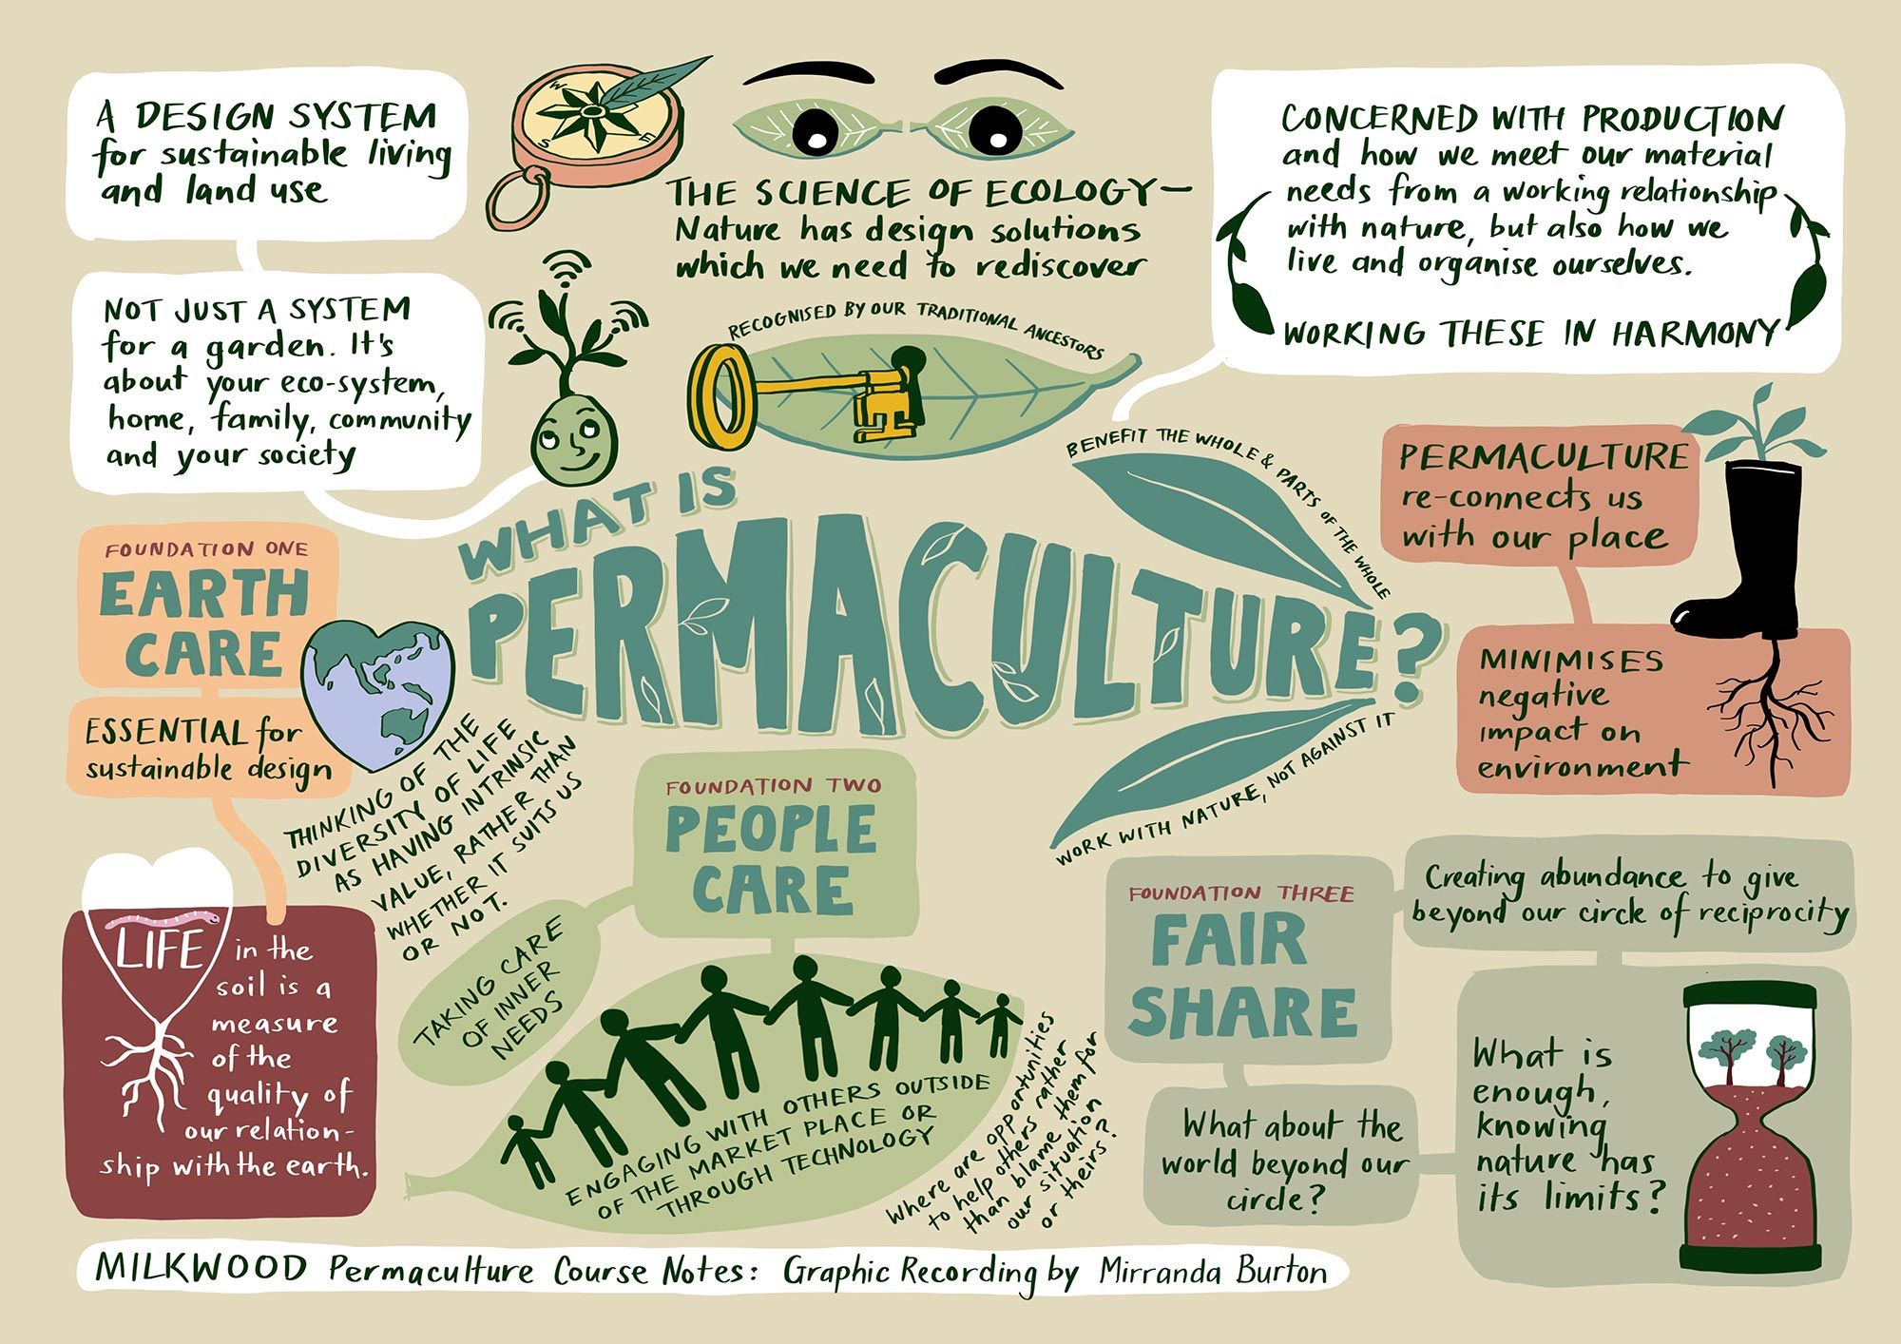
Permaculture
Value: We Learn and Achieve; We Work Together; We Respect our School and Community
In living out our school mission of Growing Hearts and Minds Together, our Permaculture Curriculum provides children with rich, meaningful opportunities to develop a deeper understanding of themselves, their community and the natural world around them. Through hands-on experiences, practical learning and environmental stewardship, children learn that they can make a positive difference to the world while developing the knowledge, skills and values that will support them throughout their lives.
Permaculture is far more than gardening. It is an approach to learning that encourages children to observe carefully, think critically and act responsibly. By engaging directly with natural systems, pupils develop an appreciation of how living things are interconnected and how sustainable choices can help protect our environment for future generations. These experiences foster curiosity, resilience, responsibility and a strong sense of belonging within their local and global communities.
The curriculum has particularly strong links with Science. Through planting, growing and harvesting, children gain first-hand experience of the life cycles of plants and animals. They investigate what living things need to survive and thrive, exploring concepts such as nutrition, habitats, adaptation and reproduction in real-world contexts. Observing seasonal change allows pupils to understand how environments evolve throughout the year, while activities such as composting help them explore decomposition, microorganisms and nutrient cycles. Children are encouraged to ask questions, make predictions, conduct investigations and collect evidence, developing the scientific enquiry skills that are fundamental to becoming successful scientists.
Permaculture also enriches children's understanding of ecology and environmental science. Pupils learn about biodiversity by creating habitats for wildlife and observing the variety of organisms that depend upon healthy ecosystems. They explore food chains and understand the delicate balance that exists within natural environments. Through discussions about climate change, resource management and sustainability, children develop an awareness of global environmental challenges and begin to understand their role as responsible citizens in addressing them.
Connections with Design and Technology are equally powerful. Children design, create and evaluate practical solutions to real-life challenges within the school environment. Whether constructing raised beds, designing watering systems, building habitats for wildlife or creating products using harvested produce, pupils apply the design process in meaningful and authentic contexts. They learn to select appropriate materials, use tools safely and refine their ideas through testing and evaluation. These experiences develop creativity, problem-solving skills and perseverance while demonstrating how thoughtful design can improve both human and environmental wellbeing.
The promotion of healthy lifestyles is another significant aspect of our Permaculture Curriculum. By growing fruits, vegetables and herbs, children develop a greater understanding of where food comes from and the importance of making healthy choices. Harvesting and tasting produce that they have grown themselves often encourages children to try new foods and develop positive attitudes towards nutrition. These experiences help pupils understand the relationship between food, health and wellbeing while promoting lifelong habits that support physical and mental health.
Importantly, permaculture contributes significantly to children's personal development. Working collaboratively on long-term projects teaches patience, teamwork and responsibility. Pupils learn that success often requires sustained effort, careful planning and resilience when things do not go as expected. Caring for plants and shared spaces nurtures empathy and respect, while celebrating harvests and achievements together strengthens community spirit and a sense of collective responsibility.
By embedding permaculture throughout the life of the school, we provide children with purposeful opportunities to connect classroom learning with the real world. The curriculum develops scientific understanding, practical skills, environmental awareness and healthy habits while fostering the values of stewardship, responsibility and cooperation. Through these experiences, our children grow not only in knowledge and understanding but also in character, truly embodying our mission of Growing Hearts and Minds Together.

Minds
Assembly Framework
Value: We Learn and Achieve; We Work Together; We are Kind and Care for each other; We Respect our School and Community
In living out our school mission of Growing Hearts and Minds Together, our Assembly Framework has been carefully designed to reflect, celebrate and support the diverse community we serve. Assemblies provide a shared experience that brings our school together, creating opportunities for children to learn, reflect, celebrate and develop a deeper understanding of themselves and the world around them.
Through a carefully planned programme of assemblies, pupils explore a wide range of themes that promote personal growth, positive relationships and responsible citizenship. High-quality texts, stories and real-life examples are used to engage children in discussions about important values such as kindness, respect, resilience, honesty, courage and empathy. These shared experiences encourage children to think critically, consider different perspectives and reflect on how they can contribute positively to their school and wider community.
Our Assembly Framework celebrates the rich diversity within our school and beyond. Children are encouraged to recognise and value the differences and similarities that make every individual unique. Through assemblies focused on inclusion, equality and cultural understanding, pupils develop respect for others and an appreciation of the many traditions, experiences and backgrounds represented within modern Britain. This helps to foster a strong sense of belonging whilst preparing children to become respectful and active members of society.
Religious festivals and cultural celebrations form an important part of our assembly programme. Throughout the year, children learn about significant events from a range of faiths and cultures, including Christmas, Easter, Eid, Diwali, Hanukkah and Lunar New Year. These assemblies deepen pupils’ understanding of different beliefs and traditions, reinforce learning from the Religious Education curriculum and promote tolerance, respect and appreciation of the diverse world in which they live.
Celebrating children's achievements is a key element of our Assembly Framework. Achievement assemblies provide regular opportunities to recognise success, effort, perseverance and contributions to school life. Whether celebrating academic progress, exemplary behaviour, sporting accomplishments, creative talents or the demonstration of our school values, these assemblies help to build confidence, self-esteem and pride in achievement. They also encourage children to celebrate the successes of others, strengthening our inclusive and supportive school community.
Singing assemblies are another valued feature of school life and make an important contribution to pupils’ wider development. Through singing together, children experience the joy of collective performance whilst developing confidence, listening skills and musical understanding. These assemblies complement and strengthen learning within the Music curriculum by exposing pupils to a range of musical styles, cultures and traditions. Singing together promotes a sense of unity and belonging, helping children to feel connected to one another and to the wider school community.
Our Assembly Framework plays a vital role in enriching children’s personal development. It provides regular opportunities for reflection, celebration and shared learning, while promoting the values and attitudes that underpin our school ethos. By bringing our community together through stories, discussion, celebration and song, assemblies help our children develop into thoughtful, respectful and confident young people, truly living out our mission of Growing Hearts and Minds Together.

Minds
Enrichment
Value: We Learn and Achieve; We Work Together; We are Kind and Care for each other; We Respect our School and Community
In living out our school mission of Growing Hearts and Minds Together, our Enrichment Programme ensures that every child has access to a wide range of experiences that broaden horizons, develop aspirations and bring learning to life. Through inclusive extra-curricular clubs, educational visits, visitors and workshops, pupils are given opportunities to discover new interests, develop talents and build confidence beyond the classroom. Our pioneering Global Voices, Careers Week and Health and Wellbeing Week further enhance children's understanding of the wider world, their future possibilities and the importance of positive physical and mental health. Together, these experiences enrich the curriculum, create memorable learning opportunities and help our children develop the knowledge, skills and character needed to thrive as confident, responsible and ambitious young people.
